Ring Oscillator Test Vector Report

The process for designing test vectors for circuit 2, the Ring Oscillator System, took a different approach to the other circuits. This is due to the nature of the circuit, as the output oscilloscope wasn’t designed to settle on a distinct value, hence any test vectors would not be able to test for this outcome. However, there were a few vectors which could be created: testing that the reset input produced no output both at the start of the test and after the ring is oscillating, and testing that when the *EnableOsc* signal was low, there was no output.

During the first lab, basic initial test vectors were created to put the oscillator into its enabled position, by resetting the oscillator and then putting both inputs to ‘1’. As the function of the circuit wasn’t going to provide a result that the test vectors could test for, the output had to be ‘X’ – don’t care – as it wasn’t possible to know the state that the oscillator would be in at any one time. During the first lab, the test vectors passed their tests on the chip, however we were unable to get a conclusive oscilloscope output in the time we had.

Prior to testing on the chip in the second lab, simulations could be run that would aid the laboratory chip testing work. Running a testbench (automatically generated from the test vectors through our ideal golden design schematic) using Modelsim provided visual aids that gave a way to check that the vectors were testing for the right functionality. As the oscillator was in an unknown state when enabled, Modelsim was unable to produce a distinct output. The test vectors tested the basic functionality of the reset and enable inputs, and the final test vector left the oscillator in it’s enabled state, so that oscilloscope measurements could be taken during the lab.

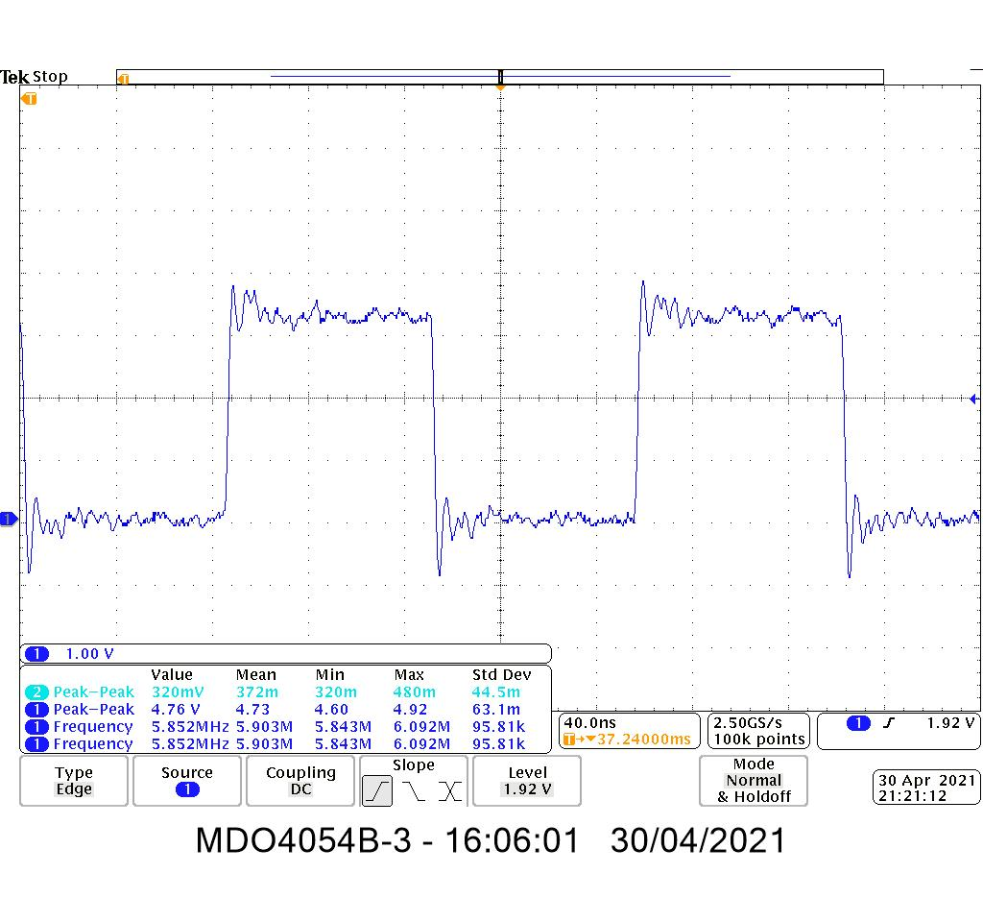

Figure X: The output from the oscilloscope measurement of testing the Ring Oscillator circuit shows the correct functionality. The frequency is recorded at 5.8MHz, 14.5% off our ideal 6.9MHz frequency.



Testing on the chip in the lab provided no errors; all the basic test vectors passed which proved the circuit was functioning correctly. However, using the oscilloscope, the frequency of the oscillator was measured to be 5.8MHz, as shown in **Figure X*.*** As the test vectors were designed to be reproducible on any ring oscillator, the results for other team’s circuits were recorded too, shown in **Appendix X.** Comparing the results of every team’s ring oscillator, the average percentage uncertainty (excluding outliers) was 16.0%. This puts our designed ring oscillator within this average, which confirms that the design of the circuit was correct, and uncertainties will have arisen from other manufacturing reasons. This uncertainty is likely due to physical effects of the produced chip, with delays in circuitry reducing the frequency that it could oscillate at, as simulations of designed schematics would not have accurately predicted this error.

Appendix X

|  |  |  |  |  |
| --- | --- | --- | --- | --- |
| **Team** | **Ideal Frequency (MHz)** | **Recorded Frequency (MHz)** | **Difference in Ideal vs Actual Frequency** | **Percentage Off Ideal Frequency** |
| A | 5.1 | 4.4 | -0.7 | 13.7% |
| B | 5.4 | 4.5 | -0.9 | 16.7% |
| C | 5.7 | 5.4 | -0.3 | 5.26% |
| D | 6.0 | 5.1 | -0.9 | 15% |
| E | 6.3 | 4.9 | -1.4 | 22.2% |
| F | 6.6 | 5.6 | -1 | 15.2% |
| G | 6.9 | 5.9 | -1 | 14.5% |
| H | 7.2 | 6.1 | -1.1 | 15.3% |
| I | 7.5 | 6.3 | -1.2 | 16% |
| J | 7.8 | 6.6 | -1.2 | 15.4% |
| K | 8.1 | 7.0 | -1.1 | 13.6% |
| L | 8.4 | 14.6 | 6.2 | 73.8% |
| M | 8.7 | 7.7 | -1 | 11.5% |
| N | 9.0 | 7.8 | -1.2 | 13.3% |
| O | 9.3 | 5.6 | -3.7 | 39.8% |
| P | 9.6 | 8.4 | -1.2 | 12.5% |